30th September 2019

###### School Closures

Mainstream pupils finish at 12.30 pm. Other pupils finish at 2.00 pm on Friday 25th October for half term. School lunch will be available on this day. School will reopen on Monday 4th November.

**School Fund**

Each child is asked to bring £3.00 per term or £5.00 for a family for **School Fund.**  ALL pupils benefit from this fund. We would ask that you forward School Fund money for first term to your child’s teacher by Friday 4th October.



**Parent Interviews**

Interviews will be held week commencing 21st October. **Mainstream pupils will finish at 12.30 pm each day that week.** School dinner is available**.**  **There will be no after school activities running this week.**

**Flu Vaccination**

The flu vaccination will be administered on Wednesday 16th October. Please return your form if you have not already done so.

**School Meals**

We cannot give a meal to children who are not on the Free Meals register without receiving payment. Dinners cost £2.60 per day. If your child arrives to school without lunch or payment, someone will contact you. If you have any money outstanding for dinners, please send it in to your child’s teacher by Wednesday 2nd October. Money is sent to the Education Authority and they require the correct amount to be lodged. If your child is eligible for Free School Meals and you have not yet applied, please contact the school office as soon as possible. ***If you are eligible, please make sure you apply for Free School Meals even if you think you may not actually use them. The Education Authority takes this into account when calculating the school budget, with a deadline of 3rd October.***

**Money**

Thank you for sending money into class in a clearly marked envelope, especially with younger children. It would also be appreciated if the correct amount could be included.

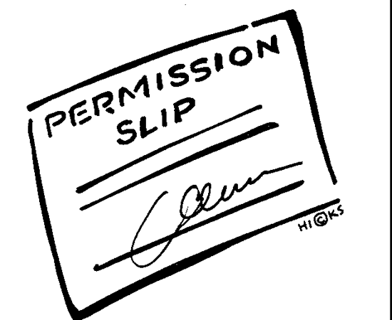

**Data Collection and Permission Forms**

Some of these forms are still outstanding. Please return them as soon as possible. Remember, we cannot include your child in a photograph with their class or on the website without your permission. Many thanks to those that have already returned theirs.

**Early Finish Friday**

Thank you for your patience as we establish the new Friday routine. Play Club and Kids Club will continue on Fridays until October half term to allow parents time to make alternative arrangements if necessary. From 4th November, Clubs are available Monday – Thursday.

**Halloween**

We will be holding a Halloween party during School on Friday 25th October. There will be a disco, games and tuck shop. There will be a charge of £1.00 for non-uniform. Fancy dress is optional.

**New Enrolment**

We are holding an information session in November for parents considering enrolling a child in Knockmore Primary School. Details to follow. Information will be available regarding The Education Authority application procedure.

**Procedures for concerns**

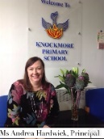If you have any concerns, the first point of contact is your **child’s teacher or classroom assistant**. An appointment can be made through the school office. If necessary, a follow-up appointment can then be made with Mr D Cunningham, Designated Teacher (Head of Units and SENCO) or Ms A Hardwick, Deputy Designated Teacher.

**Healthy Break**

Healthy Break orders for this term have all been registered and we hope the children will enjoy their snack. If you wish to book Healthy Break for November, booking forms and money must be returned to school by Monday 21st October. Cost is £5. Orders are made with a local provider and we cannot add children after the closing date of 21st October.

**Sensory Sensations Workshop**

The final day for booking a place at the Sensory Sensations Workshop is tomorrow, Tuesday 1st October. Cost £5.00 per pupil.

**Extra-curricular Activities**

Our Clubs have been fully booked on some days during September. Remember to pre-book early as bookings are taken on a first come, first served basis. *We cannot exceed our pupil/staff ratio and will return bookings if a Club is full.* We would also remind parents that if a child is booked into a Club, they are expected to attend for the full session and should be collected at finishing time at the correct door. Please do not arrive early to the office to pick up your child, unless in an emergency.

‘Little Chefs’, ‘Film Club’ and ‘ECO Club’ commence week beginning 30th September for KS2 pupils. Bookings are now closed. Remember: 4pm pickup at the back gate at bottom of steps.

**Christmas Fair**

We look forward to welcoming you to our Annual Christmas Fair on **Thursday 5th December** from 6 – 8 pm. We do hope you, your family and friends will attend. We will have lots of interesting stalls and Father Christmas will be in attendance.

**Sickness**

If a child experiences diarrhoea or vomiting, they should not come into school for at least 24 hours after the last episode.

**Dates for your diary:**

16th Oct – flu vaccination

21st Oct – Closing date for Healthy Break for November.

Mon 21st Oct – Fri 25th Oct – school finishes at 12.30 pm for Mainstream Classes. Parent interview week.

Fri 25th Oct school finishes at 2.00 pm for all other classes.

There are no extra-curricular activities that week and Play Club and Kidz Club are not available.

25th Oct – Halloween Party

Mon 28th Oct – Fri 1st Nov – half term holiday

5th Dec – Christmas Fair